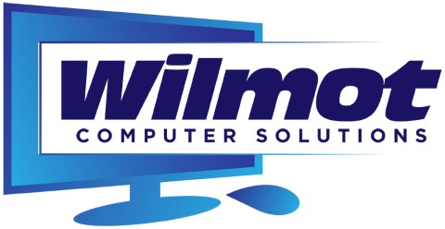
Managed Services Plan 2017
MONITORING
24/7/365 Monitoring – Weekly Reports Emailed
-Automatic Program and Operating System Patches Improves PC Performance and Security
-24/7 Health Check can identify issues early
-Coverage includes Monitoring, Disk Space, Managed AntiVirus (BitDefender), Internet Security, Hardware, and Performance
SECURITY
-Desktop/ Laptop Protection
-Hacking/ Failed login detection
-Malware Prevention
-Policies and Guidance
Web Protection (Internet)
-Filtered Access Options
-Desktop/Laptops on the move, are protected from websites pushing malware, phishing sites, proxies, spyware and adware, botnets, and SPAM.
-90% of Attacks come from Malicious Websites. Without this level of protection, it’s all too easy for users to stray onto websites, which might appear safe, but can actually deliver a malicious payload to their computer. Besides the time and cost of cleaning up viruses and the loss of productivity from malware slowing down systems, there are bigger risks to consider. When passwords are stolen through a phishing attack, there can be devastating results for a business, including reputation damage, data breach and loss of intellectual property.

Continuity
Coverage: AntiVirus, Internet Protection, Monitoring, Automated Patches, Performance, Security, Hardware, Disk Health, Policies and IT Governance.

All Current Customers Pricing as Follows
Total Cost per PC/Laptop is approximately 50 cents a day, Billed Monthly at $15 per, Quarterly at $45,
Bi-Annual $90, or Annually at $180

New Customers/Businesses
Residential $25 Monthly or $250 Annually per Desktop/Laptop
Business $45 Monthly or $450 Annually per Desktop/Laptop
Discounts can apply with Multiple Units

FREE 30 DAY TRIAL

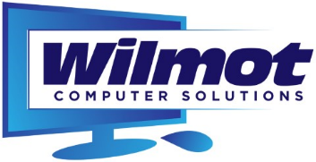

Tom Wilmot – Owner
WilmotCS.com
Facebook.com/WilmotCS
Twitter @WilmotCS
224-484-0456
Mail@WilmotCS.com

